Assignment 3
08/09/2026
1. Workflow — Assign Task
- Setup → Workflow Rules → New Rule
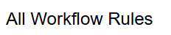
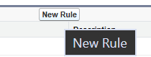
- Select Applicant as the object → Next.
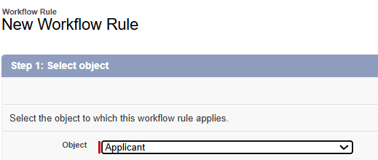
- Enter Rule Name: WR1.
Set Evaluation Criteria: Created.
Set Rule Criteria: Police Verification = True.
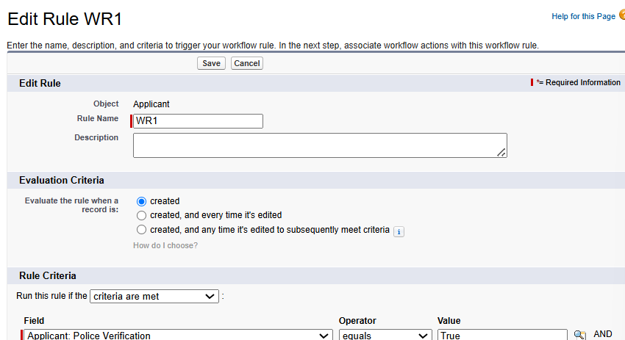
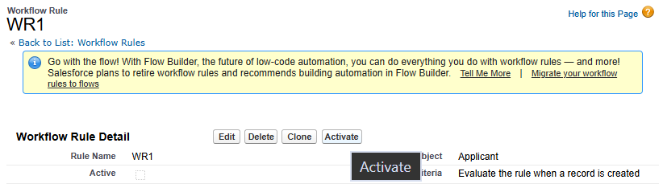
- Click Save & Next → Add Action → New Task.
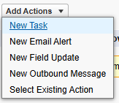
- Enter: Assigned To: Bunty Modi, Subject: Car Follow-up, Status: In Progress, Priority: High, Due Date: Created Date + 1 day.
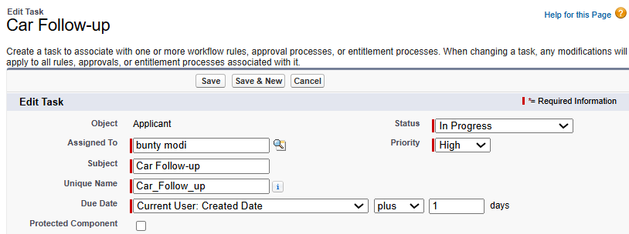
- Click Save → Done → Activate. Then create a new Applicant with Police Verification = True to test.
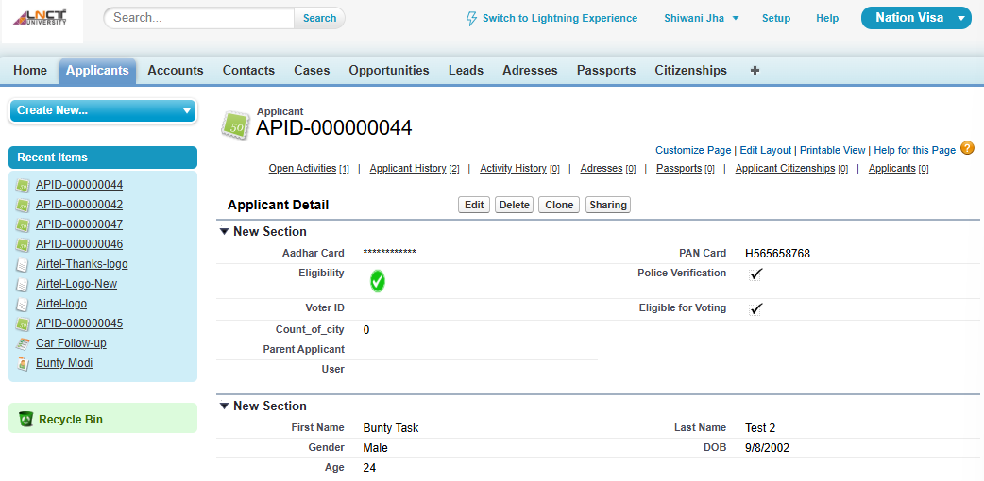
Result-
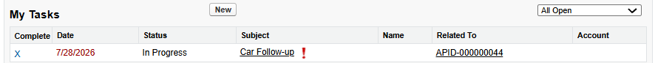
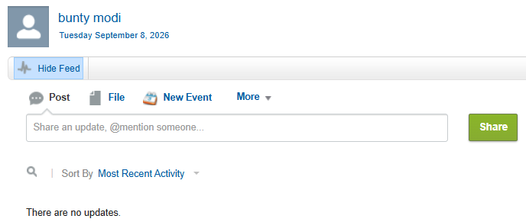
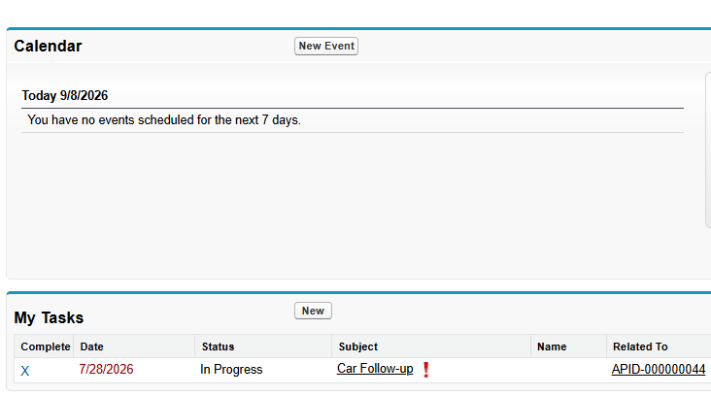

2. Letterhead + HTML Email + Email Alert
- Setup → Letterheads → New Letterhead.
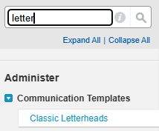
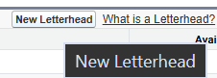
- Enter Letterhead Name: Welcome Email Letterhead. Check Available for Use.
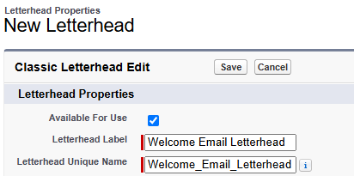
- Add required logo/header/footer. Click Save.
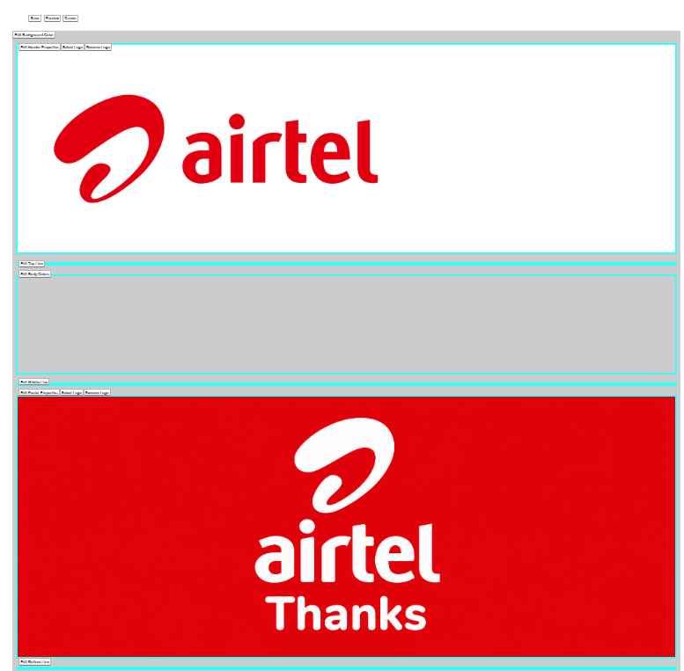
- Go to Setup → Classic Email Templates → New Template.
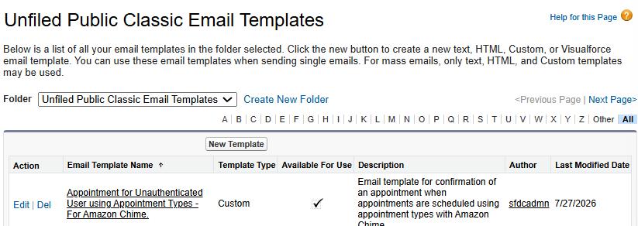
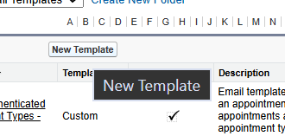
- Select HTML (using Letterhead) → Next.
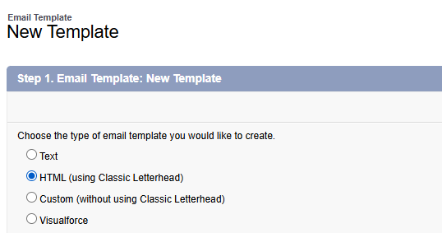
- Select Folder and check Available for Use, Letterhead: Welcome Email Letterhead, Template Name: Welcome Email Template, Subject: Welcome to Airtel.
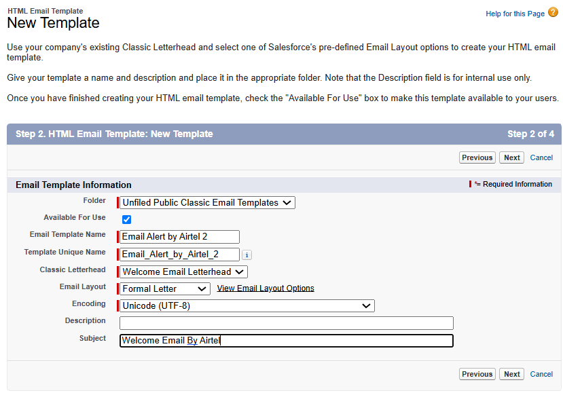
- Add the HTML email body and insert required Applicant Merge Fields.
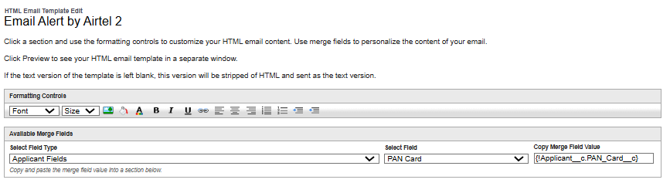
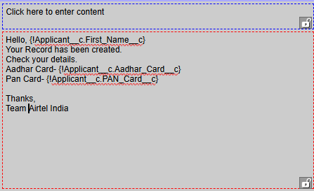
- Go to Workflow Rule → Add Workflow Action → Email Alert → New Email Alert; select Applicant, Welcome Email Template, and Email Field → Email ID.
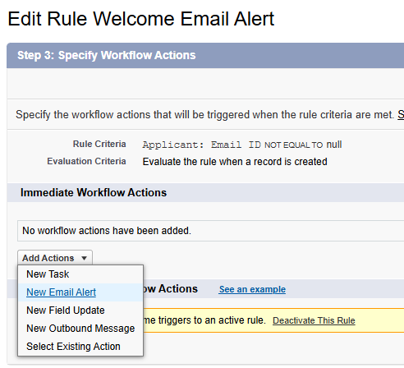
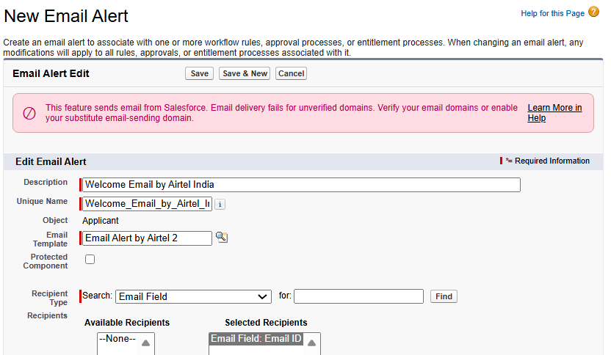
- Click Save → Done → Activate, then create a new Applicant with a valid Email ID and test the email.
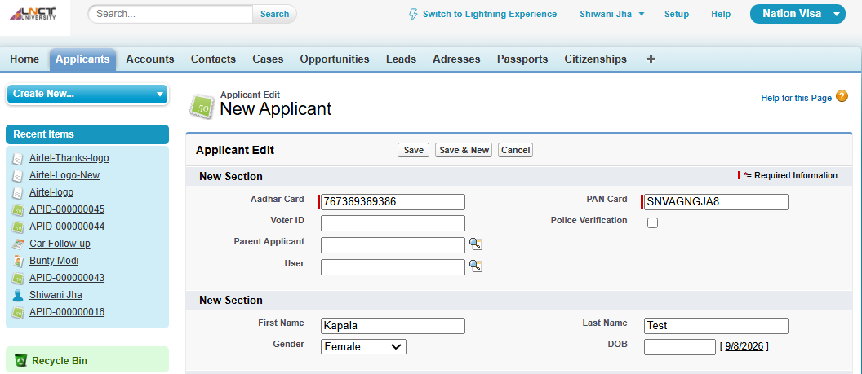
Mail received in Spam Folder-
